# PROFILO BIOGRAFICO DI EILEEN ‘IKE’ WEST

**Eileen ‘Ike’ West** è scrittrice, insegnante e fondatrice del *DGDI Advisory Group*, un comitato di professionisti che aiutano le tribù dei nativi americani a sviluppare un futuro sostenibile e a trovare il supporto economico necessario per mettere in atto i loro progetti.

E’ autrice del romanzo *Away From Hannah’s Castle* (USA 2006).

Susan Smith dedica ad Ike un intero capitolo nel libro *Wise Women – Donne sagge* (NL 2003) che include altre figure di donne molto stimate, come Isabel Allende, Jane Goodall, e la regina Noor di Giordania.

Negli ultimi trentacinque anni, Ike West ha tenuto conferenze e seminari, sia in Nord America che in Europa, in cui offre ai partecipanti intuizioni ed argomenti di ampio respiro per mantenere un livello ottimale di salute e felicità, e condivide allo stesso tempo la profonda saggezza di quei popoli che pongono l'amore e il rispetto per la Terraalla base della loro spiritualità.

Dal 1980 numerosi articoli di Ike West sullo sviluppo della consapevolezza e le connessioni tra mente, corpo e spirito sono stati pubblicati in USA e in altri paesi.

Attualmente Ike vive nella regione montuosa nei pressi di Austin,Texas (USA)

*Per ulteriori informazioni, consultare i siti web:*

[www.ikewest.com](http://www.ikewest.com)

[www.AustinWestWellness.com](http://www.AustinWestWellness.com)

[www.AustinWestWriting.com](http://www.AustinWestWriting.com)

[www.awayfromhannahscastle.com](http://www.awayfromhannahscastle.com)

# *Costo del seminario completo*

# 300 CHF - 280 EUR

*Costo delle singole lezioni*

VENERDÌ 75 CHF / 70 EUR

SABATO 150 CHF / 140 EUR

DOMENICA 150 CHF / 140 EUR

*Tariffa studenti*

per intero seminario 250 CHF

a giornata 100 CHF

* Si prega di riservare con largo anticipo.

Iscrizione entro il 1°.03.2020

* L’iscrizione sarà ritenuta valida dopo il versamento della quota di iscrizione presso:

**Banca Raiffeisen, Piano di Magadino, 6596 Gordola**

**Intestato a Petra Hartmann, 6605 Locarno Monti**

**IBAN CH55 8028 0000 0022 5108 2**

**Riferimento: Ike West**

**Bic: RAIFCH22**

* Per motivi organizzativi, il corso avrà luogo soltanto se verrà raggiunto un numero minimo di 15 partecipanti.
* Si consiglia di portare: materiale per scrivere, una bottiglia d’acqua, vestiti comodi e cuscini.

**Le lezioni si terranno in lingua inglese con traduzione in italiano.**

*Orario*

VENERDÌ 20.00 - 23.00

SABATO 14.00 - 20.00

DOMENICA 14.00 - 20.00

*Iscrizioni*

**Petra Hartmann**

**Ufficio 091 743 37 55**

**Mobile 079 696 44 87**

**Email** **elvistours@bluewin.ch**

SEMINAR WITH **EILEEN ‘IKE’ WEST**

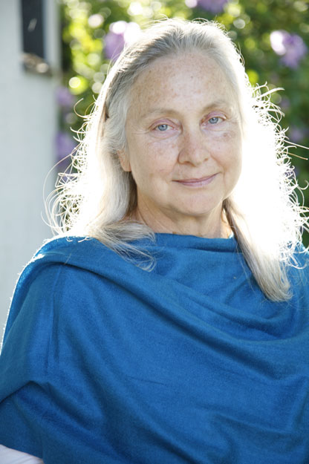

*Attivista per la crescita della coscienza individuale,*

*scrittrice, docente, e fondatrice del DGDI Advisory*

*Group, un comitato di professionisti che aiutano i*

*nativi americani a sviluppare un futuro sostenibile.*

**PLACE IN TICINO-CH**

**PROGRAM OF SEMINAR**

**Friday 27 march 2020**

From 20.00 - 23.00

**Healing Ceremonia Evening**

**Saturday 28 march 2020**

From 14.00 - 20.00

**Ancestral Power: Tap It for Today—And Tomorrow**

**Sunday 29 march 2020**

from 14.00 - 20.00

**Everyday Rituals Promoting Health & Happiness**

**Friday 27 march 2020**

**from 20.00 – 23.00**

**Healing Ceremonia Evening**

People of vision often participate in ceremony to experience the fulfillment of their gifts. Ceremonies take people beyond their own power into other realms. As ceremonial leader, West guides people through a set of rituals to attain a state of consciousness that is available in no other way. Through ceremony participants work to heal the spirit body, which in turn impacts the physical, emotional and mental bodies. The evening includes a short introduction to the connections made to the Spirits guiding the Ceremonial Circle. Participants are helped to relax and then expand awareness of the astral or light body, balancing the energy centers and clearing the auric layers.

**Saturday 28 march 2020**

**from 14.00 – 20.00**

**Ancestral Power: Tap It for Today—And Tomorrow**

We are not only humans, but beings of a grand universe where we share our consciousness with a pool of invisible spirits, many of whom are our ancestors. Now is the time to assert that powerful awareness into our lives, but first we must know what it entails, and how to welcome the ancestral energetics in noble ways. According to new paradigm theorists world-wide, the call to acknowledge universal consciousness in general, and our ancestors in particular, is strong. Join West’s circle to learn of familial consciousness that helps us incorporate positive aspects of the historical past, and re-introduce spiritual capacities known and practiced by generations in our own families—many just waiting to be tapped. Explore the open-ended processes that allow us to resonate with the cosmic caretakers, and take our places in the great community of spirit beings active around earth at this time.

**Sunday 29 march 2020**

**from 14.00 – 20.00**

**Everyday Rituals Promoting Health & Happiness**

This class highlights a mix of spiritually-imbued techniques that can be useful in the establishment, maintenance and/or restoration of balance and harmony in life. West introduces the idea of accepting multiple levels of personal growth taking place simultaneously, and how to integrate aspects of the newly-developed self, avoiding the sensations of being pulled in many directions, or worse, feeling broken apart and exhausted as a result. The tools shared in the class can be used again and again, each time imbalance arises and pressure exerts itself from the outside, or internal stress manifests as illness or disease. The seminar includes ceremonial work to open ourselves and invite in the lucidity now transforming spiritually-active people on earth. This course offers essential guidance in consciousness-raising for people awake and involved in the ongoing evolution of humanity.